1. Changes to previous week:

a.) Updated Actor-System Interaction Model to match the procedure and display of the GUI

2. UI Prototype:

| 0. Machine displays message prompting user to select cycle. |
| --- |

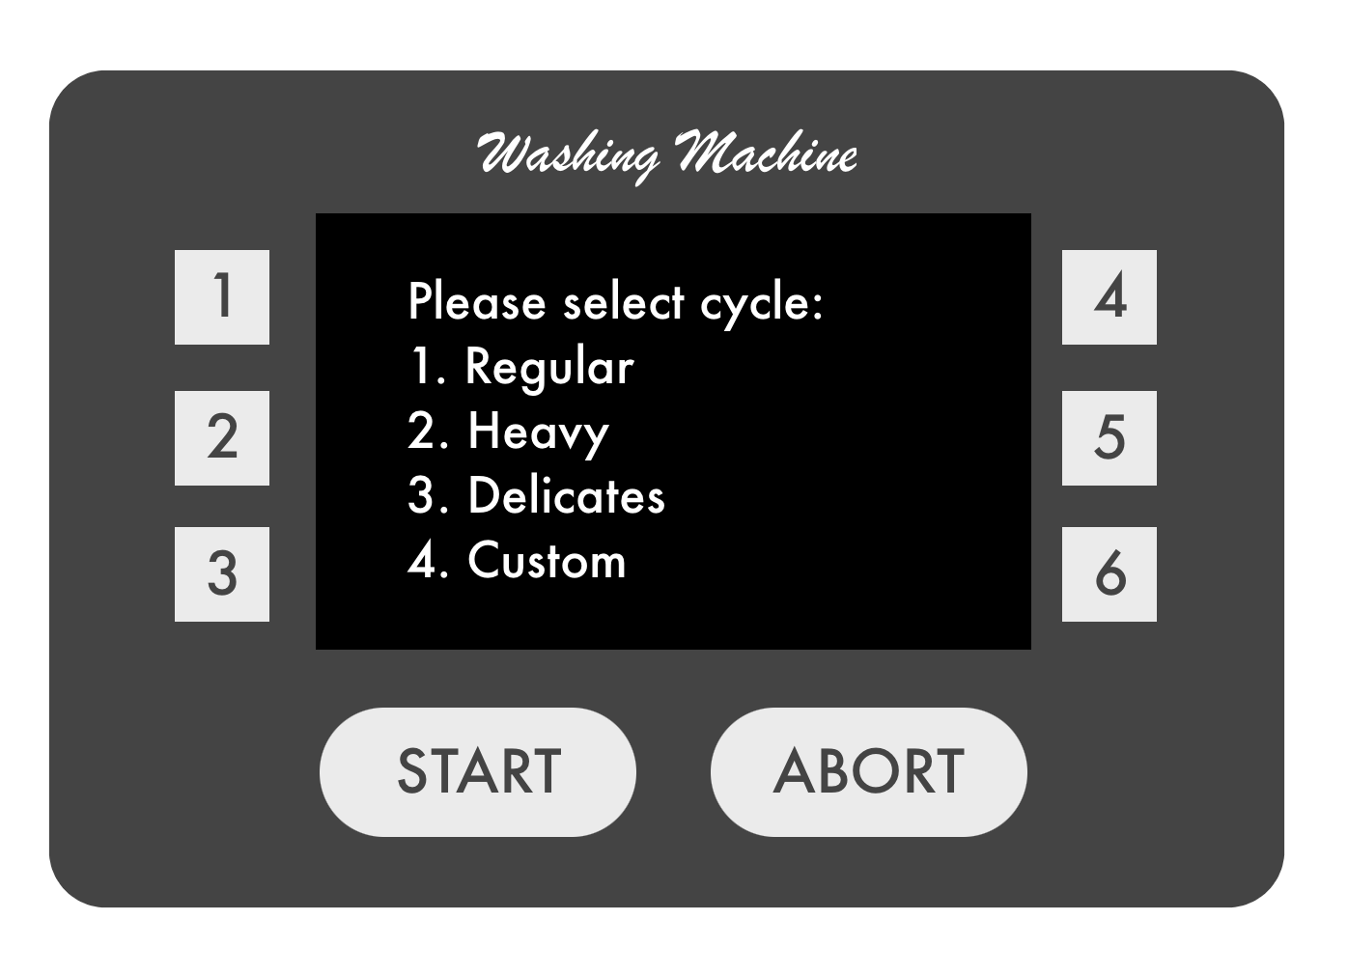

| 1. TUCBW customer selects a cycle option |
| --- |

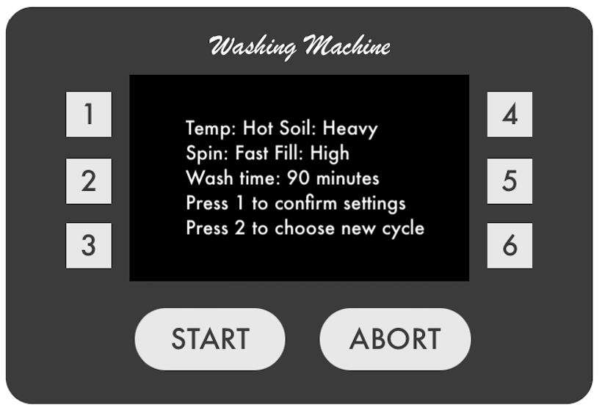

| 2. Machine displays message showing the customer the settings for the cycle chosen and prompts the user to confirm or choose new cycle. |
| --- |

| 3. The customer selects:  1.) confirm settings  2.) choose new cycle | 4. Machine accordingly:  1.) Displays the cycle price  2.) Returns to choose cycle screen |
| --- | --- |

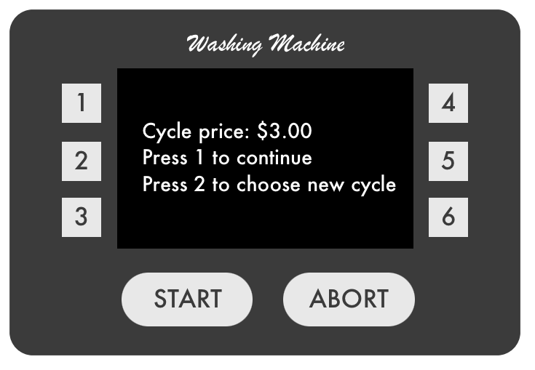

| 5. The customer selects:  1.) continue  2.) choose new cycle | 6. Machine accordingly:  1.) Continues to payment  2.) Returns to choose cycle screen |
| --- | --- |

| Precondition: The customer must have already selected and confirmed a cycle |
| --- |

| 0. Machine displays message prompting user to insert quarters. |
| --- |

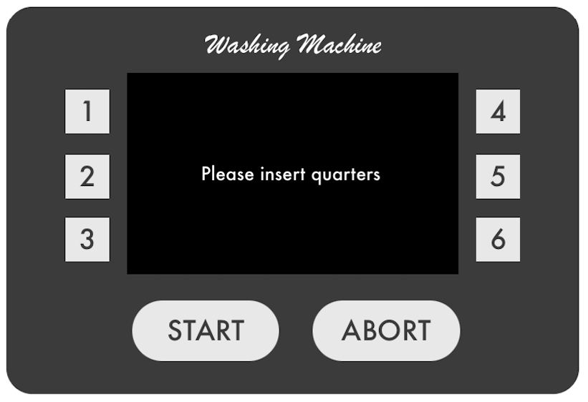

| 1. TUCBW the customer inserts quarters |
| --- |

| 2. Machine displays the value of the quarters inserted |
| --- |

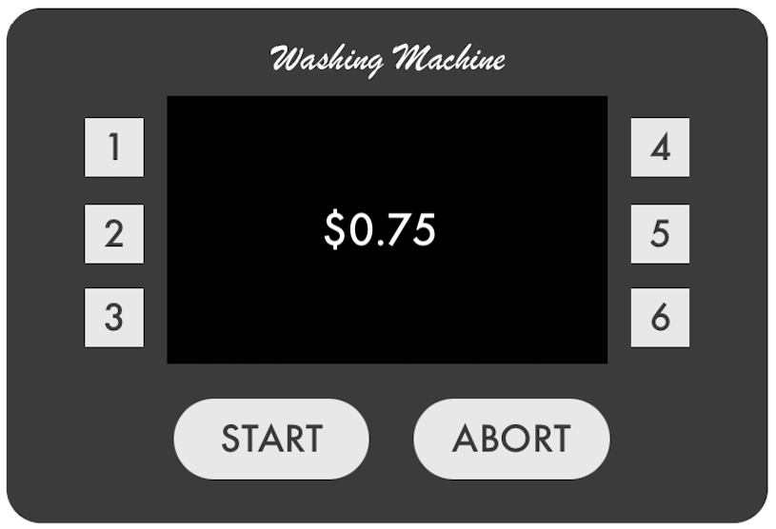

| 3. Customer:  1.) continues entering quarters until they equal the value of the cycle  2.) presses the coin return button | 4. Machine accordingly:  1.) displays message prompting user to confirm payment  2. returns coins and returns to choose cycle menu |
| --- | --- |

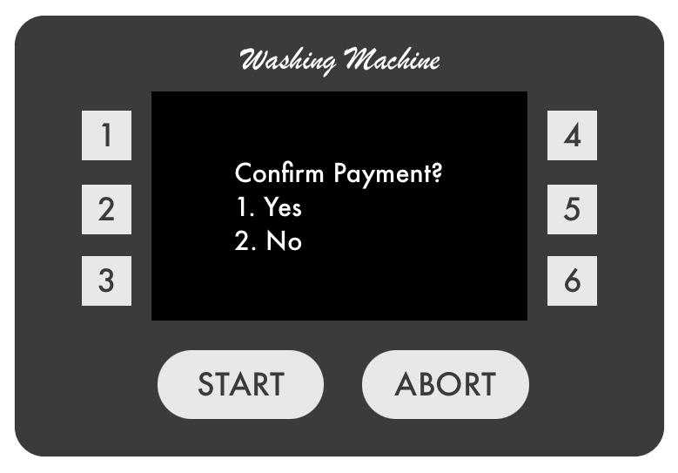

| 5. Customer:  1.) chooses “Yes” to confirm the payment  2.) chooses “No” to cancel the cycle | 6. Machine accordingly:  1.) prompts user to insert their laundry  2.) returns coins and returns to choose cycle menu |
| --- | --- |

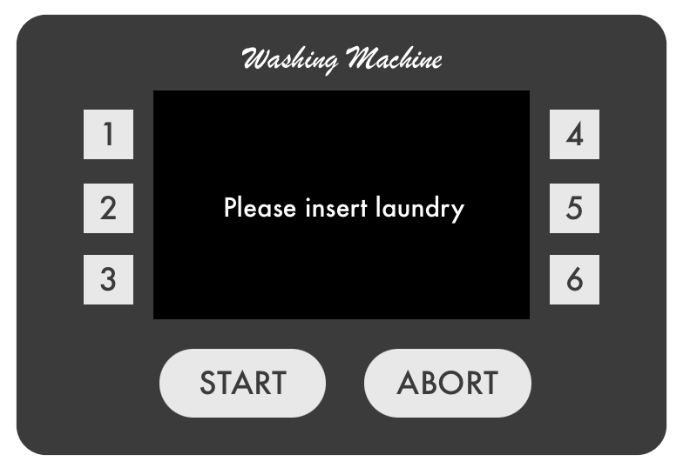

| 7. Customer opens door and inserts their laundry |
| --- |

| 8. Machine prompts user to close the door (once finished loading laundry) |
| --- |

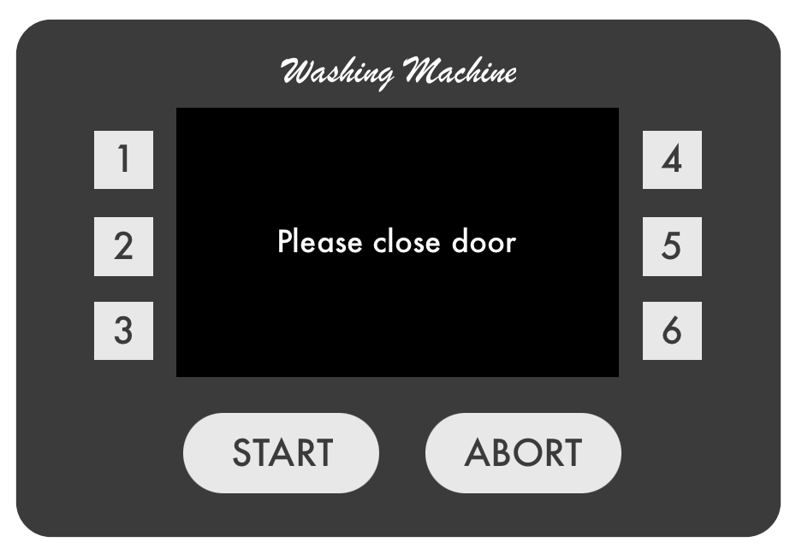

| 9. Customer shuts the door |
| --- |

| 10. Machine prompts user to press the start button to begin cycle |
| --- |

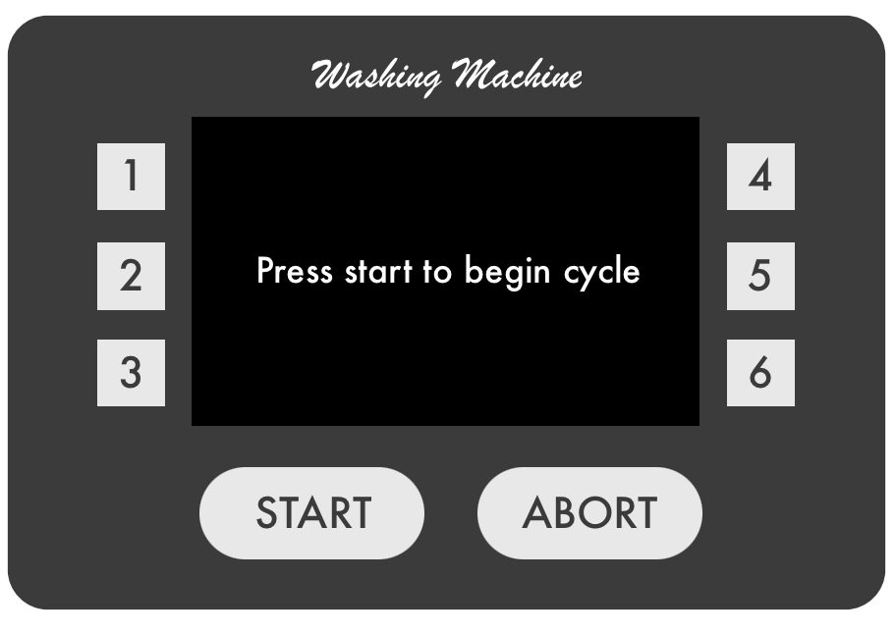

| 11. TUCEW the customer presses the start button to begin the cycle |
| --- |

| Precondition: The cycle has been started and is currently in progress |
| --- |

| 1. Employee presses the abort button |
| --- |

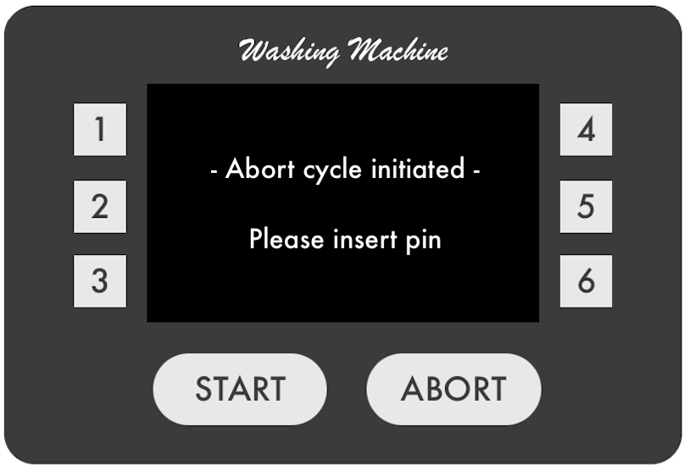

| 2. Machine prompts employee to enter their pin to confirm the abort process |
| --- |

| 3. Employee:  1.) Enters the pin correctly  2.) Enters the pin incorrectly | 4. Machine accordingly:  1.) Aborts the cycle and returns to choose cycle menu  2.) Displays message of incorrect pin and prompts user to try again |
| --- | --- |

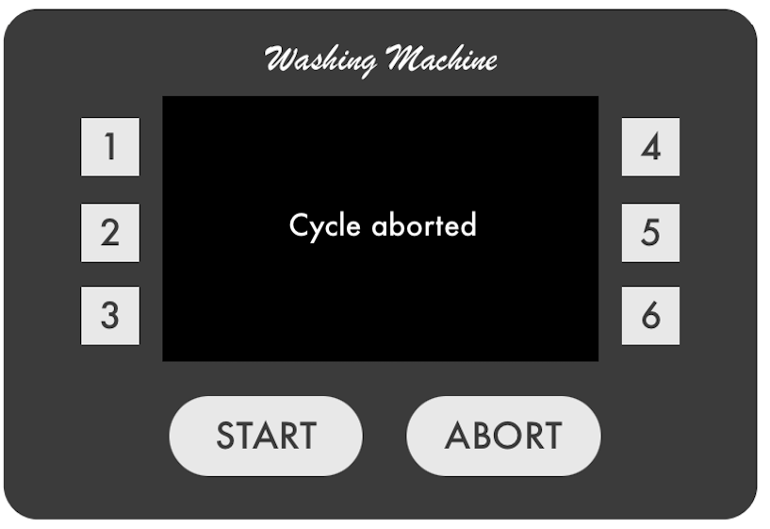

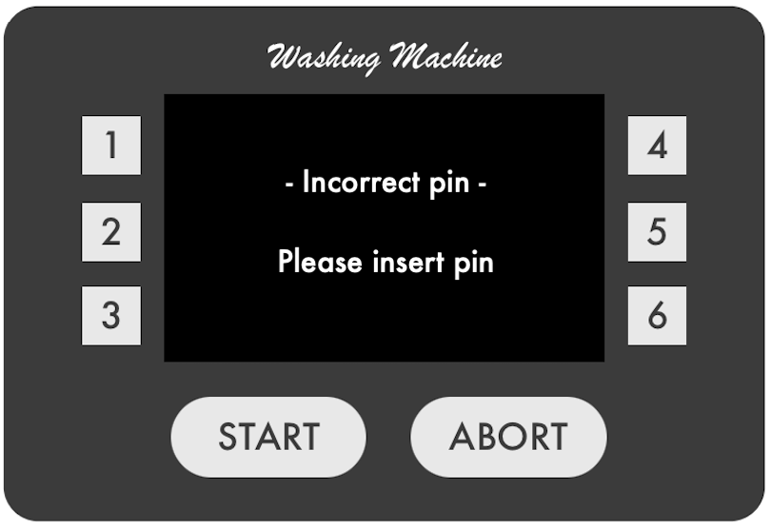

| 5. Employee enters pin incorrectly 3 times | 6. Machine cancels the abort cycle process and finishes washing |
| --- | --- |

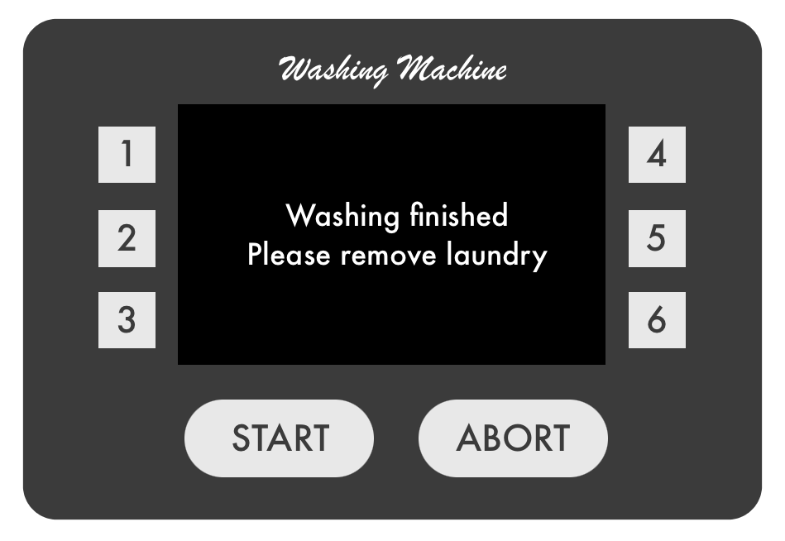

**Controller.cpp**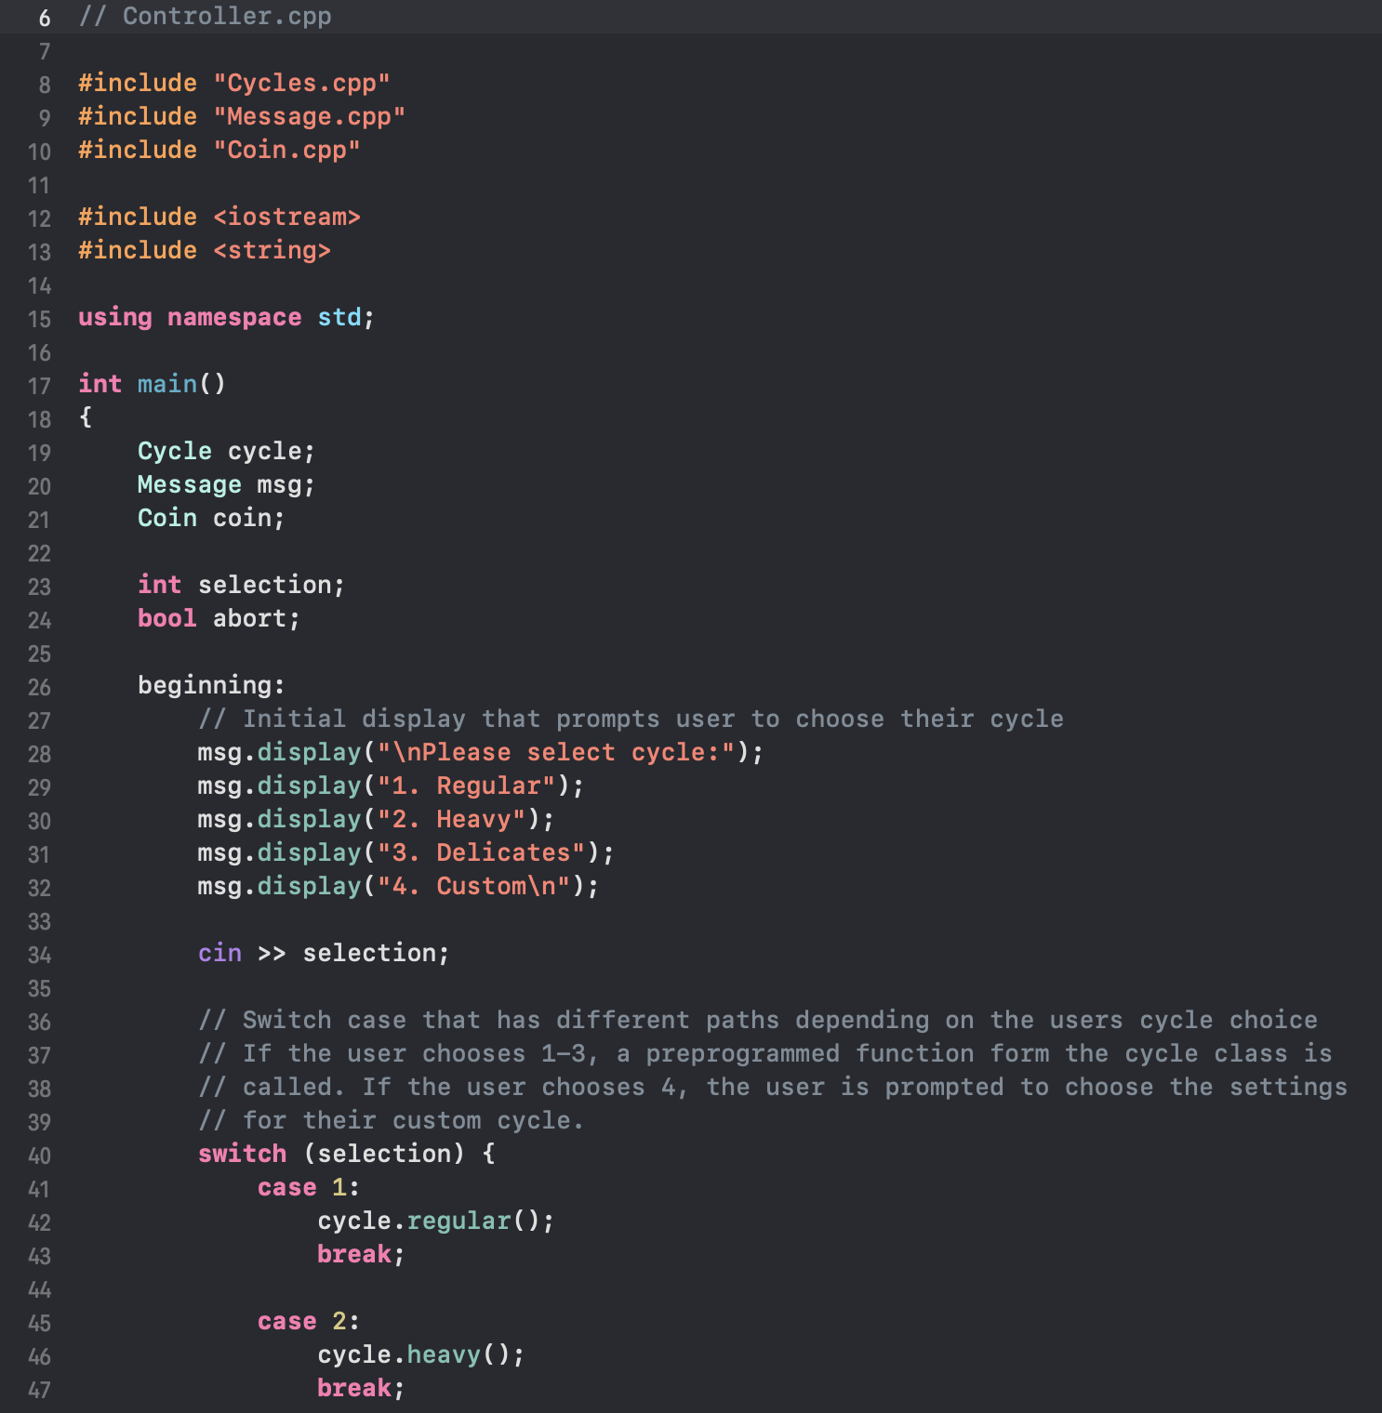

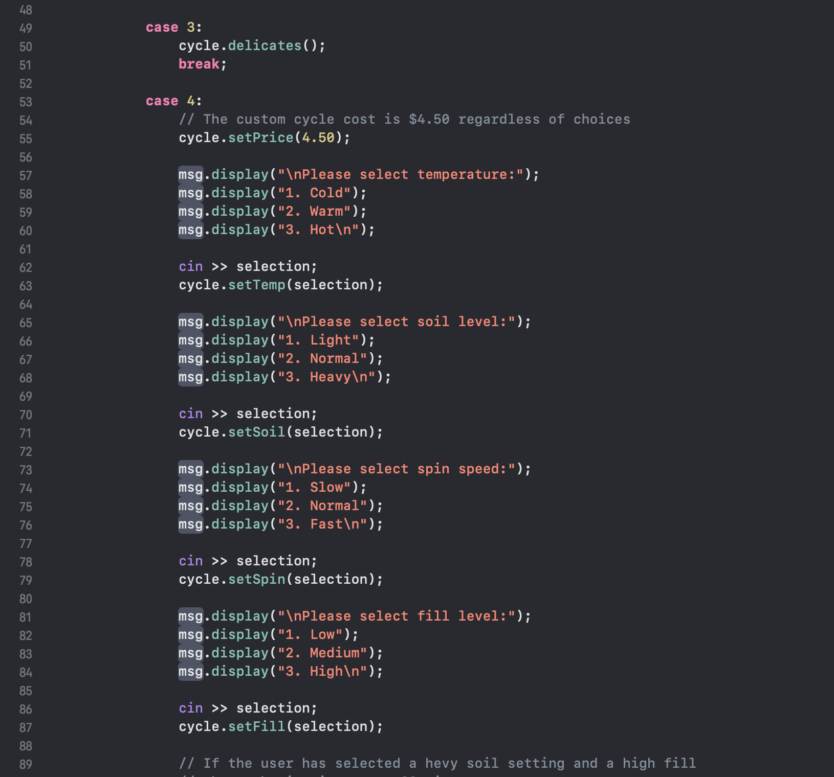

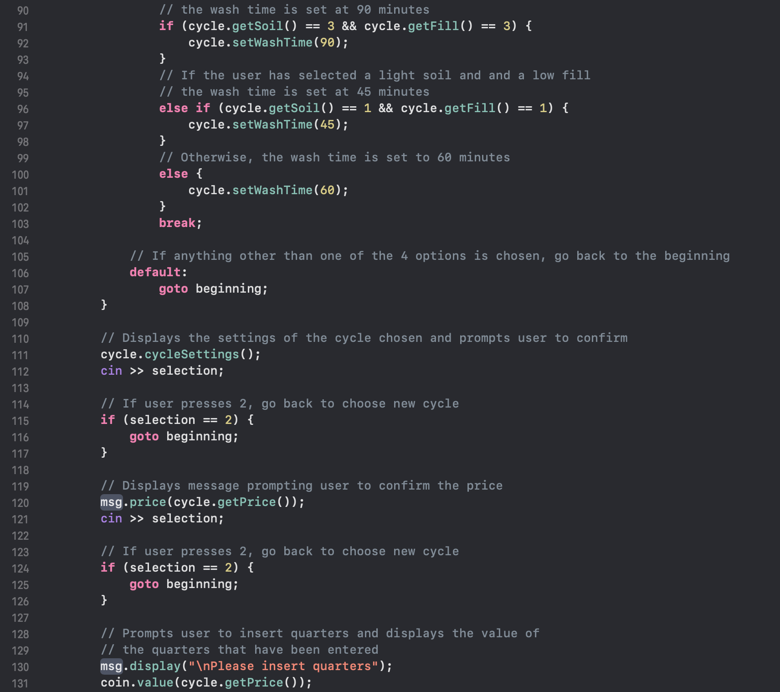

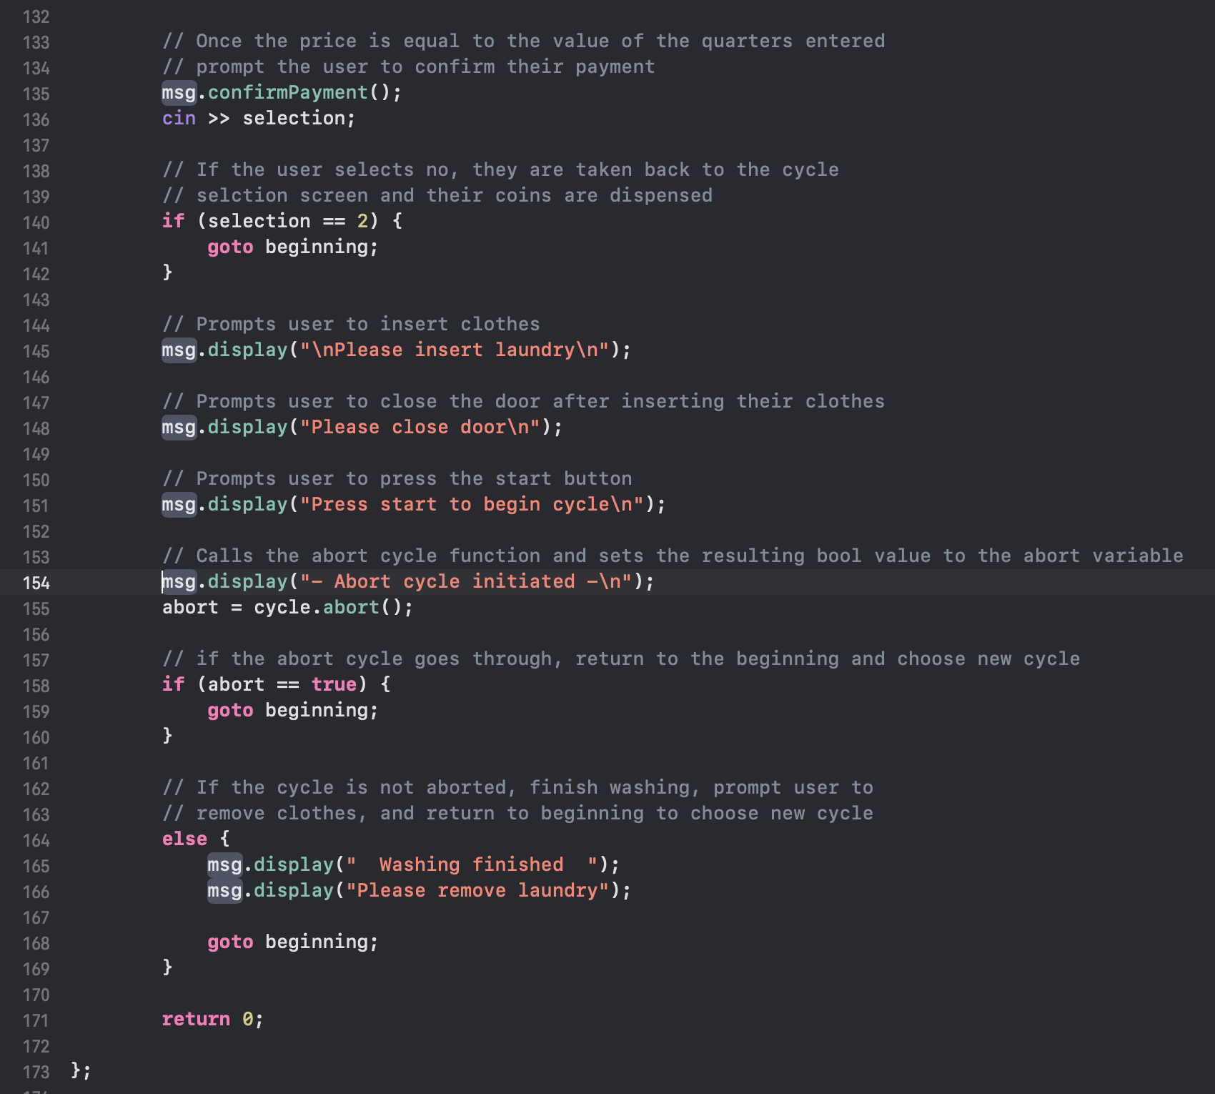

**Cycles.cpp**

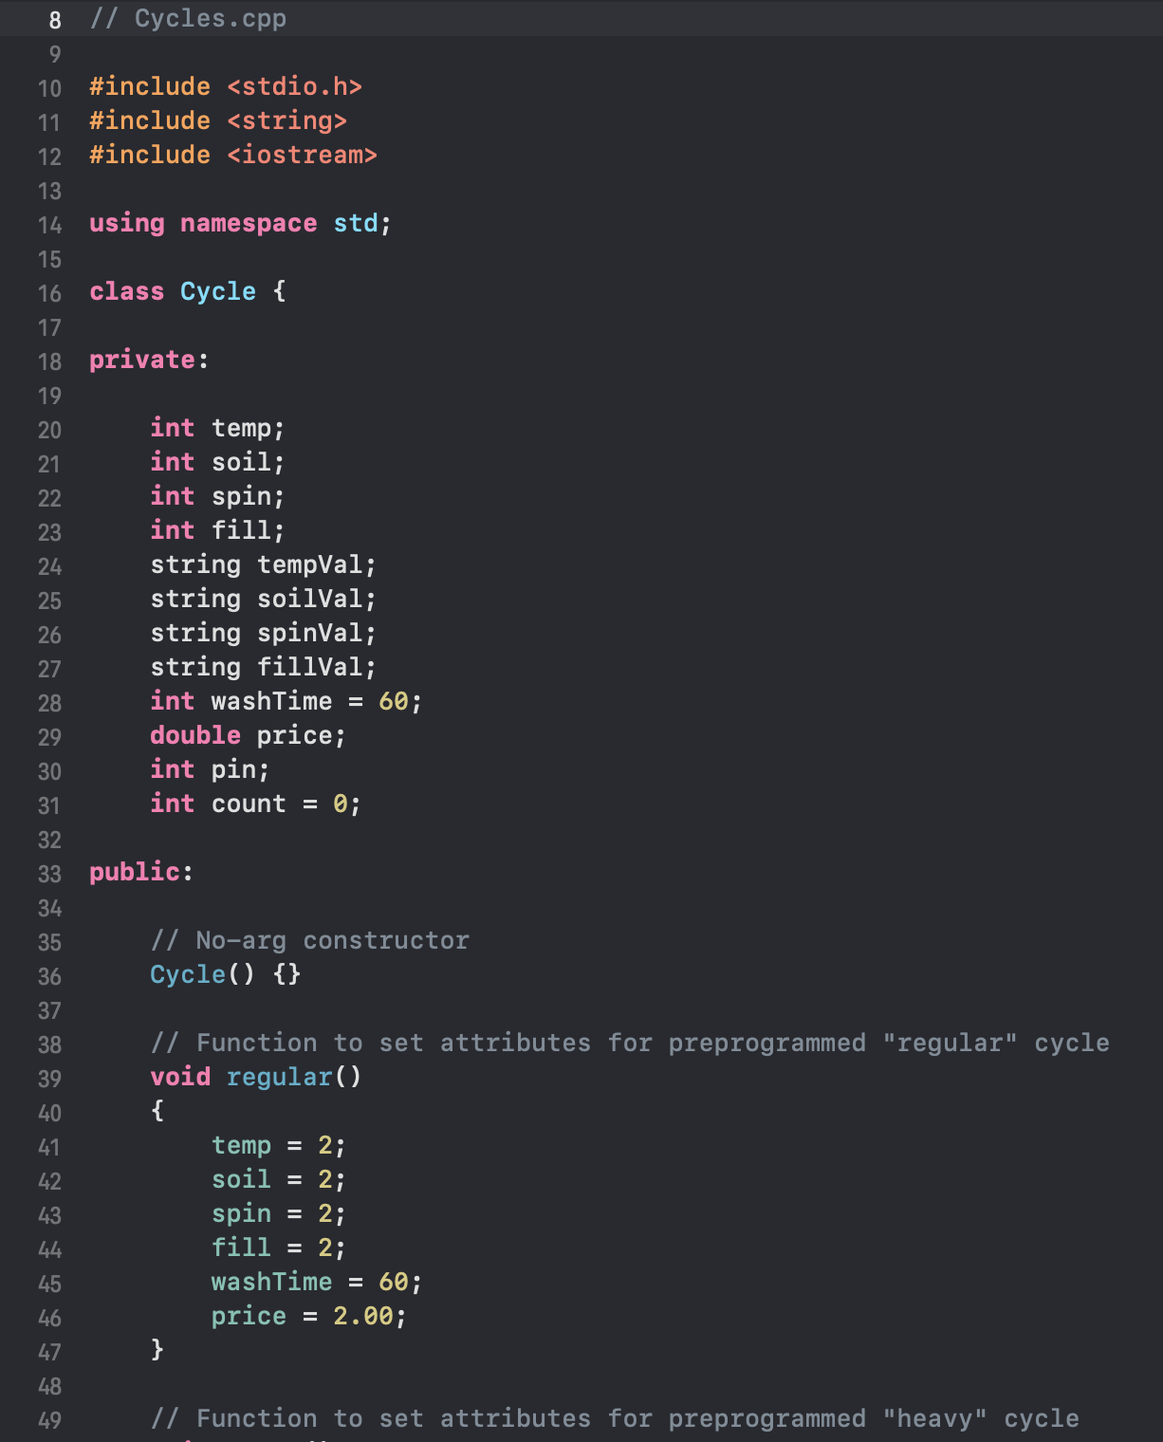

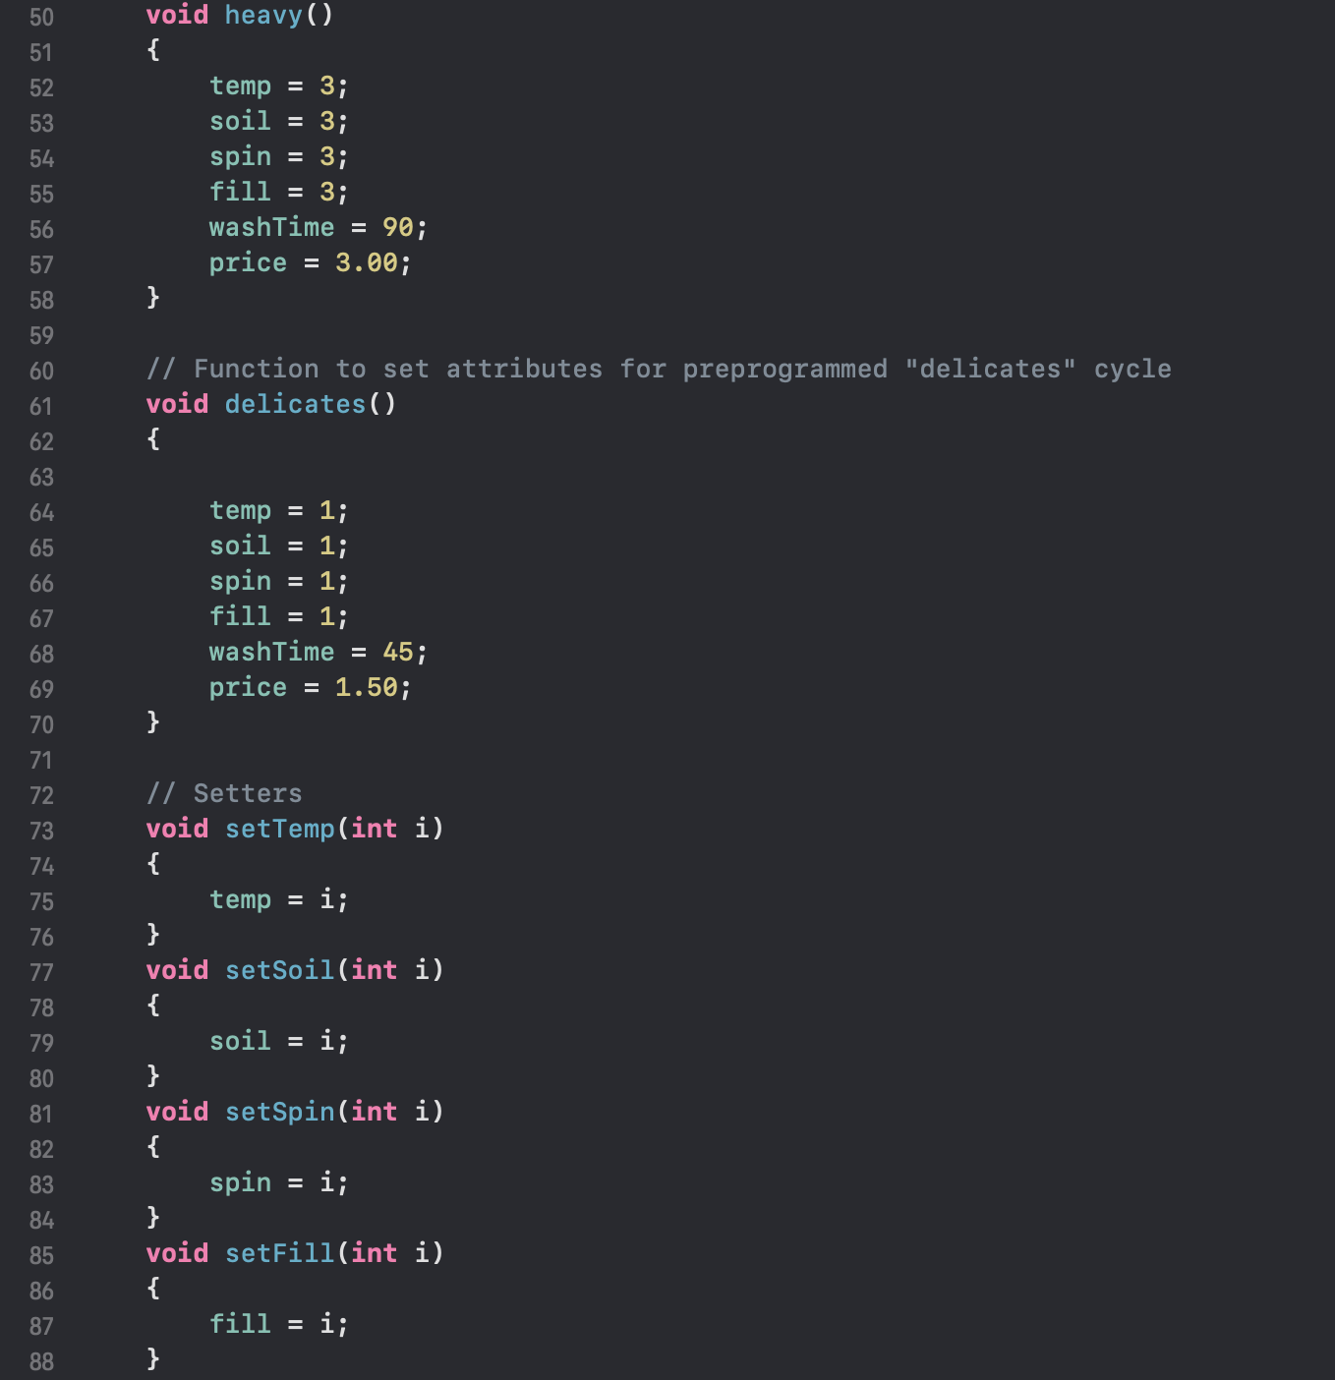

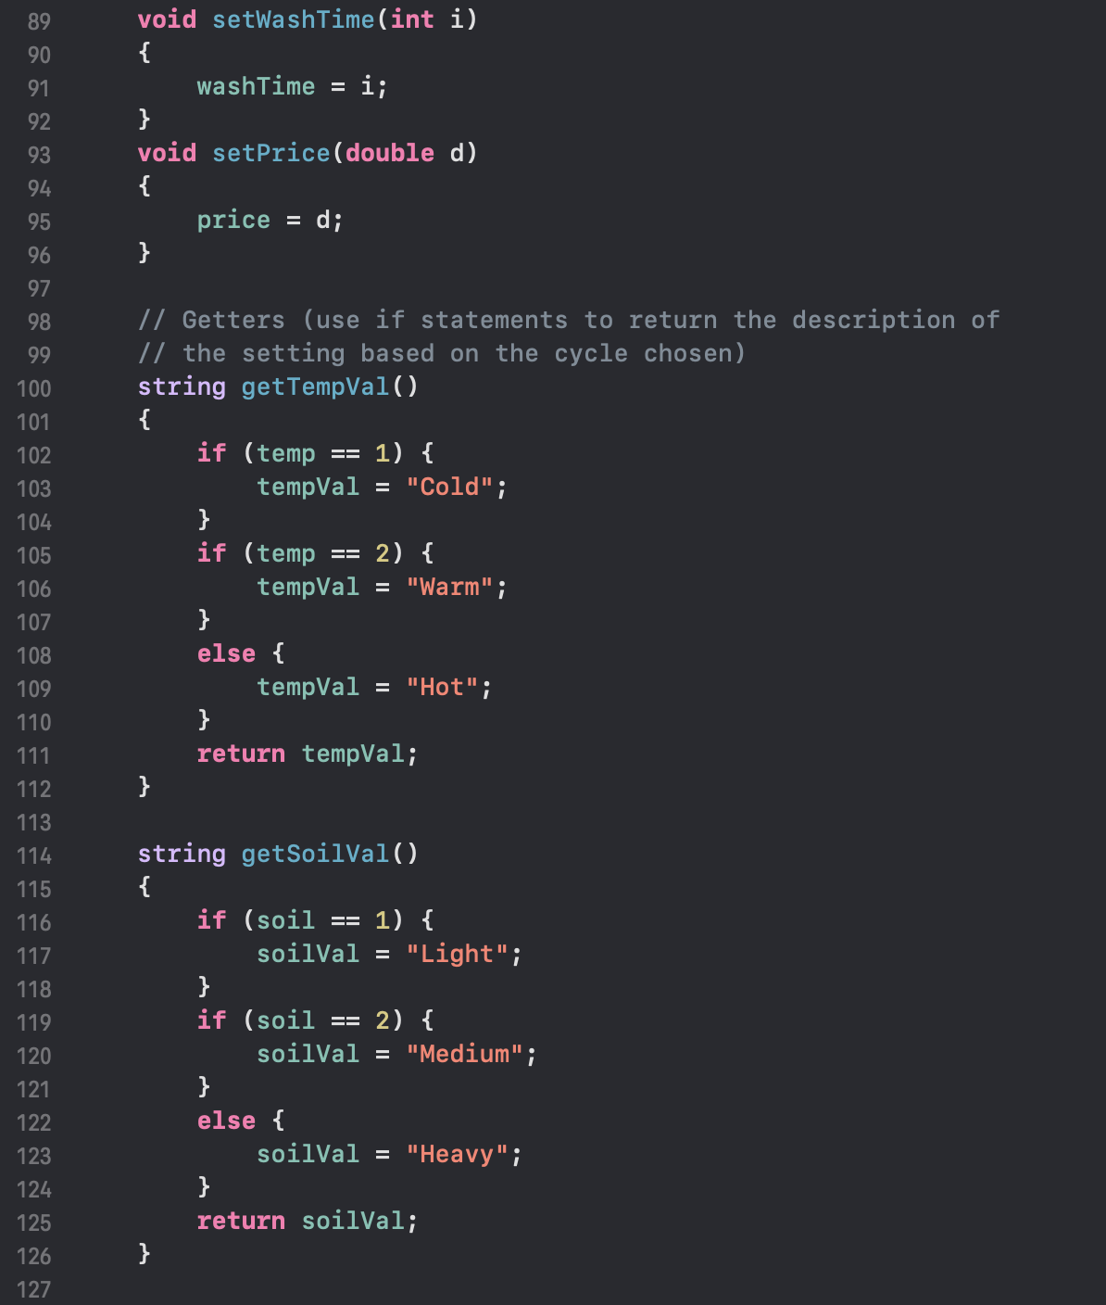

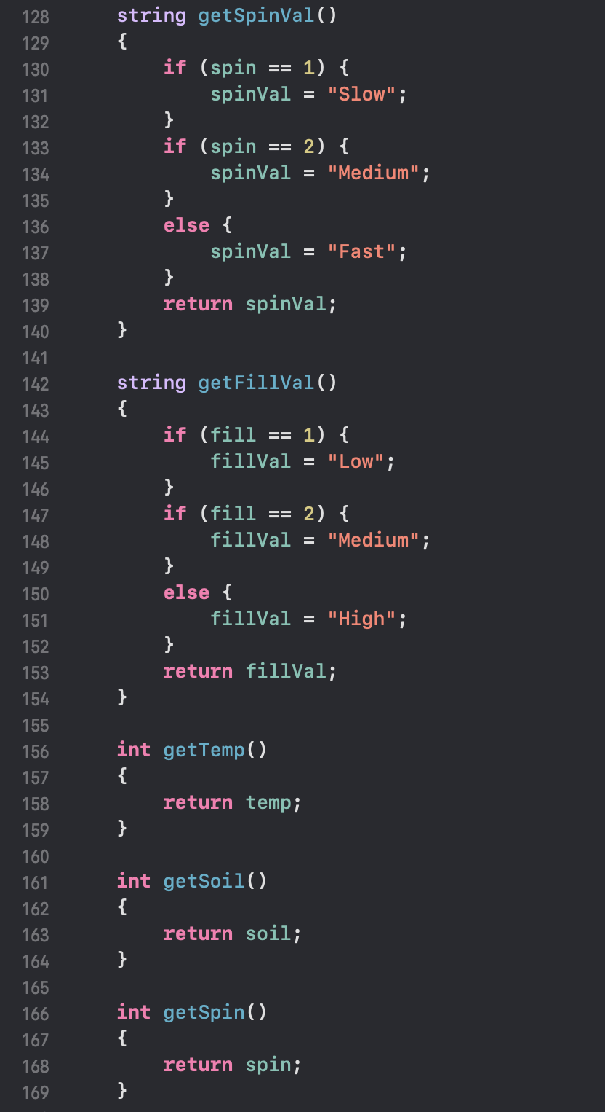

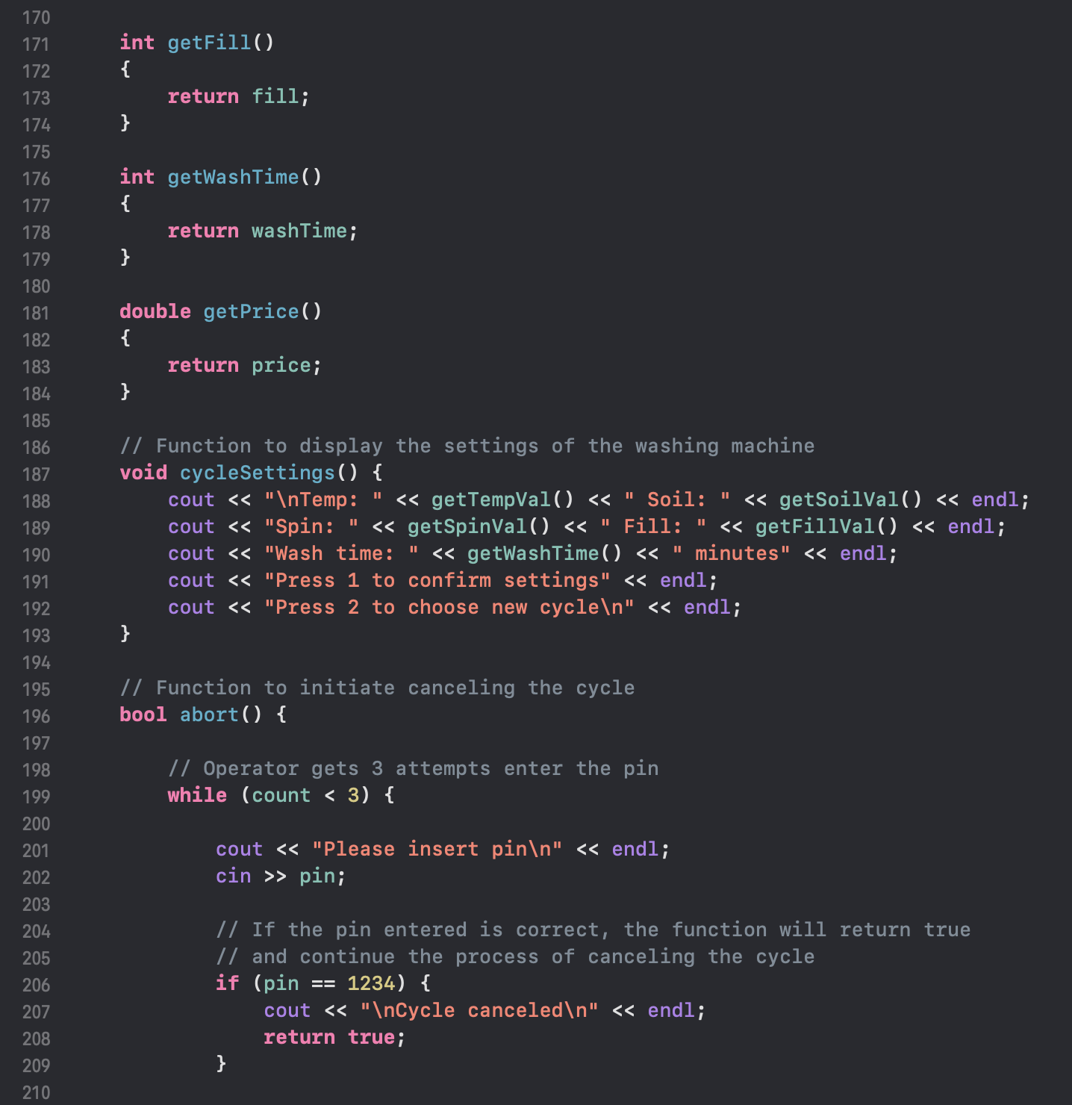

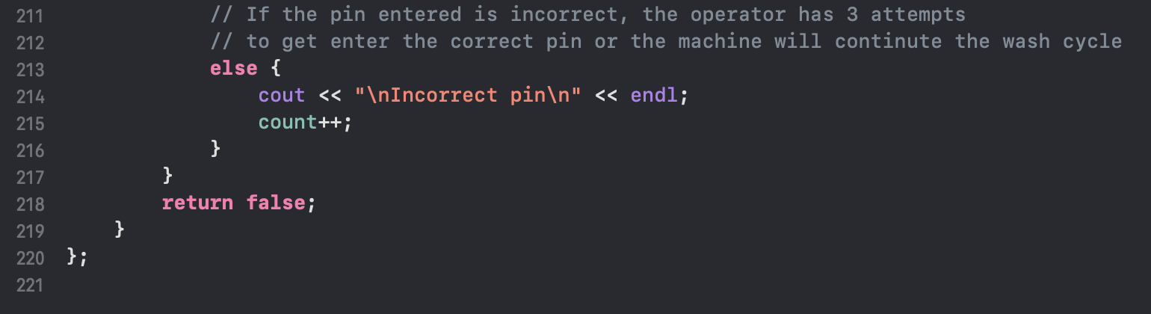

**Coin.cpp**

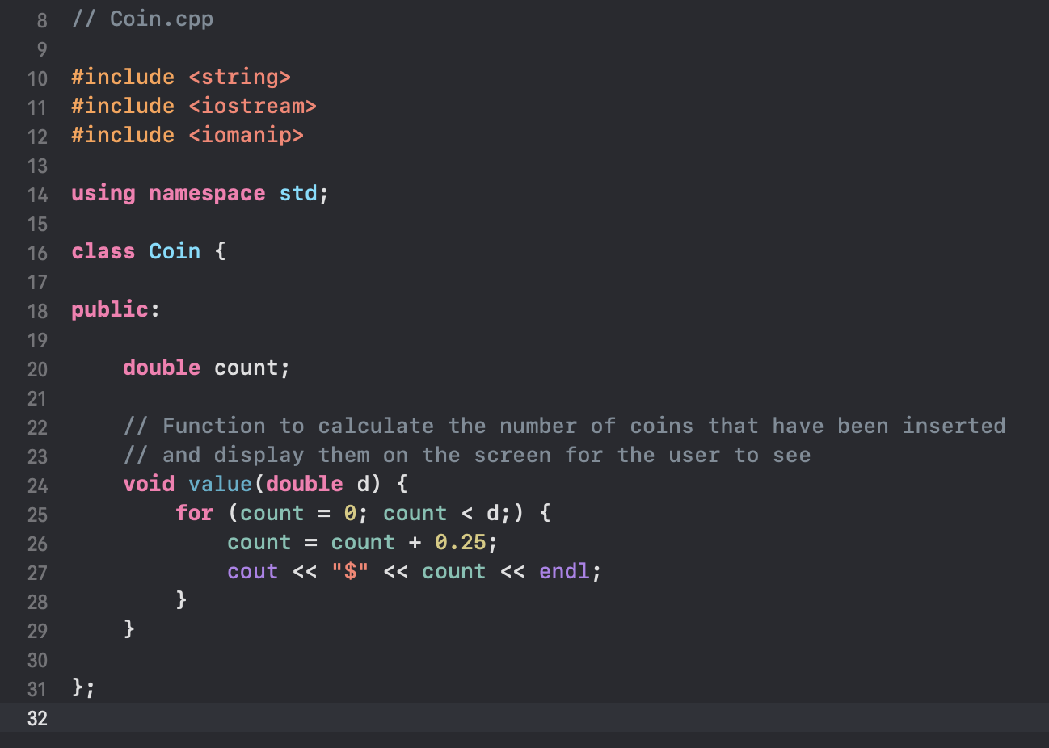

**Message.cpp**

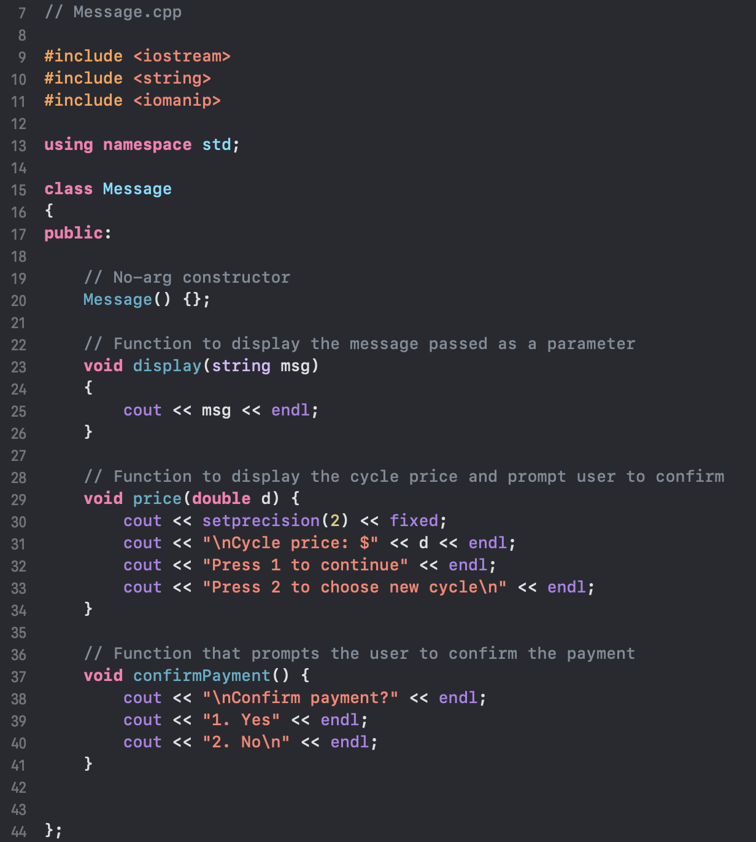

**Output Screenshots**

